**Correlation&Regression Analysis**

1. **perform correlation analysis between other variables**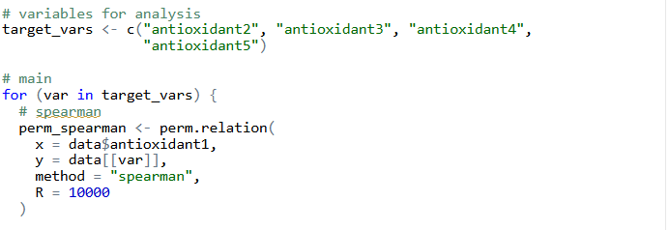
2. **obtain a table with correlation coefficients with significance assessment (permutation method)**

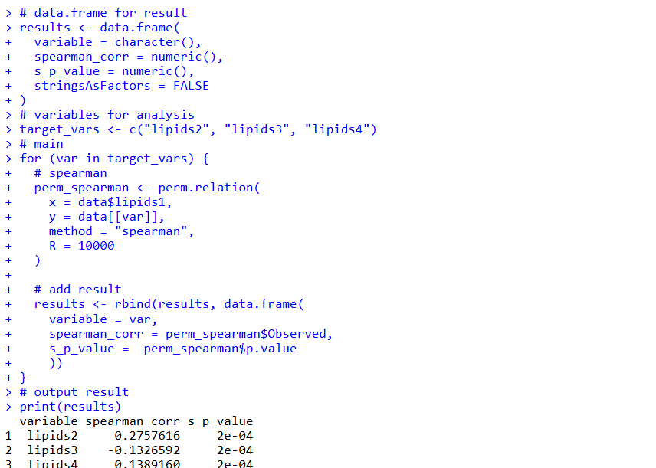

I also performed correlation analysis between hormone and antioxidant:  
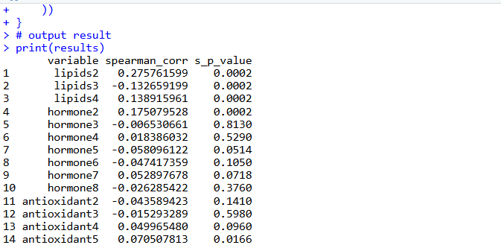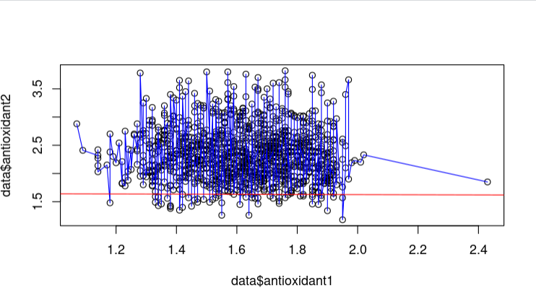

1. **perform regression analysis between other variables**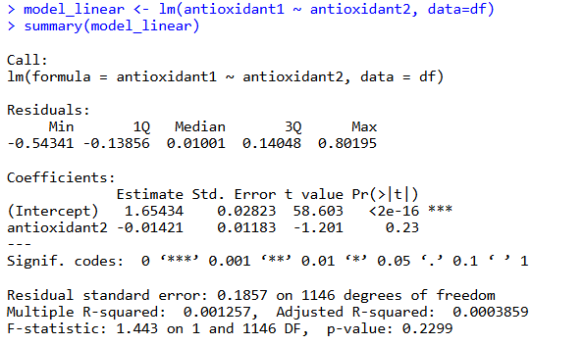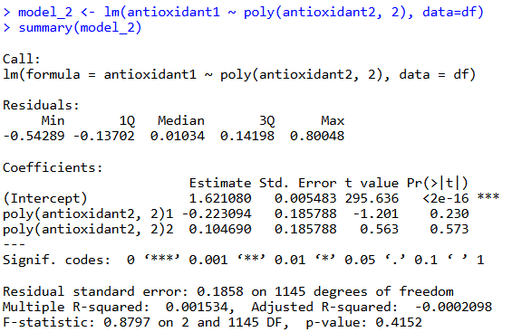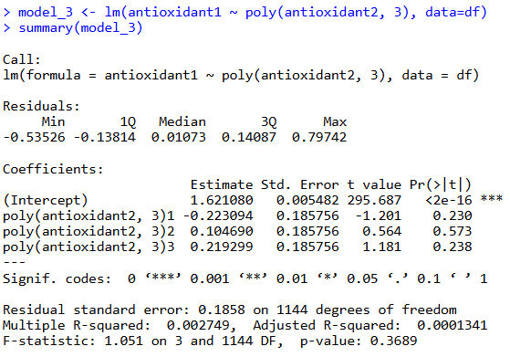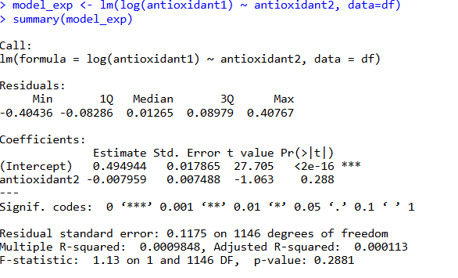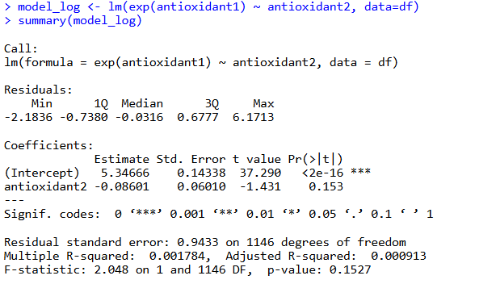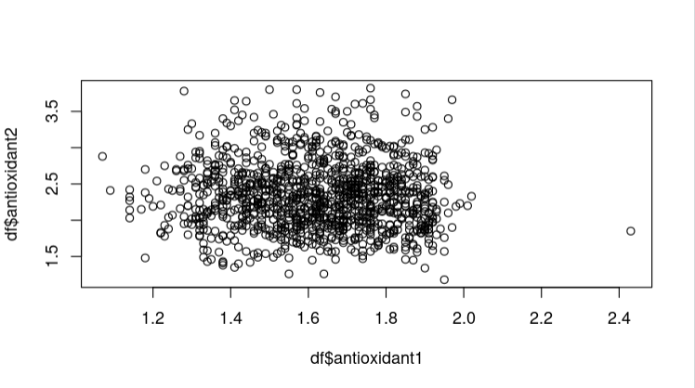

linear regression graph

1. **select the best model (BIC)**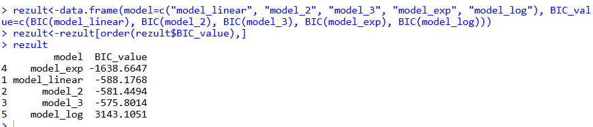

Normally, the lower BIC_value is, the better model performes. In this case the BIC_value has reached negative value, theoretically negative value is ok but if BIC_value is too low the model could be overfitting. So my answer to the best model is model_linear.